Papers written by Australian Maths Software

SEMESTER TWO

MATHEMATICS METHODS

UNITS 3-4

2017

SOLUTIONS

SECTION ONE

1. (6 marks)
(a) (i)
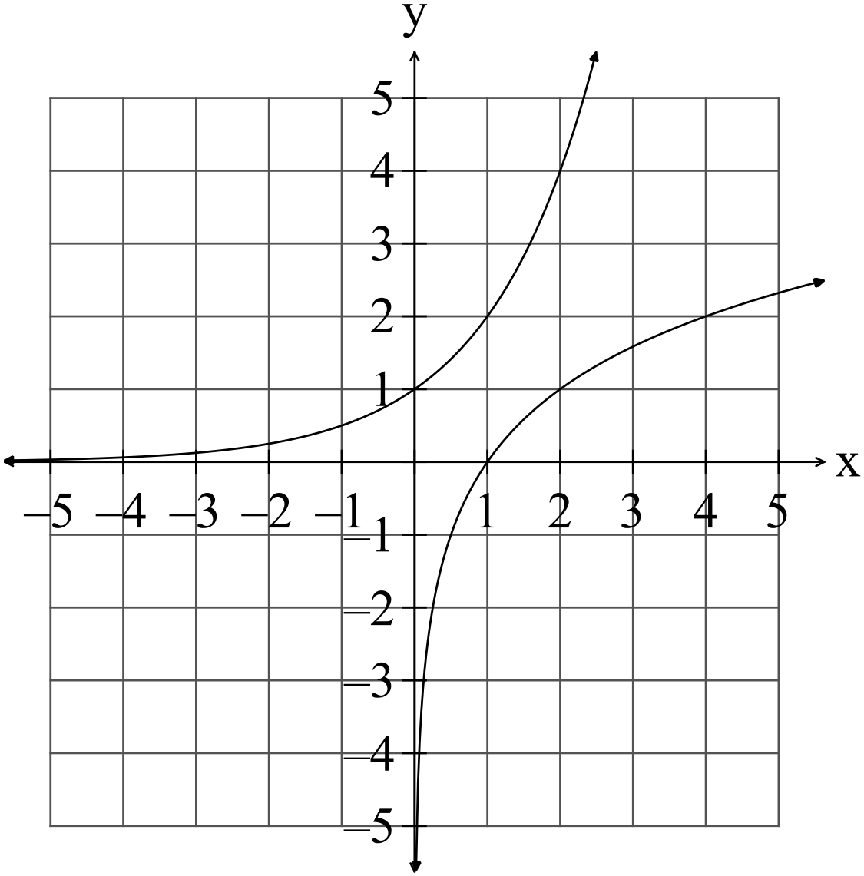
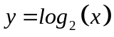
✓✓

(2)

(ii) is the inverse of 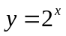 i.e. the graphs reflects about the line 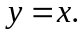
✓

If hen the andvalues are swapped around, then you obtain the expression for the function but in the form 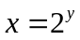. (1)

(b) Prove that 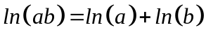.
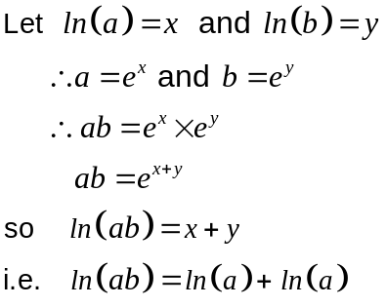.
✓

✓

✓

(3)

2. (9 marks)
(a) (i) 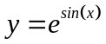
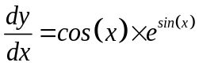 (1)
✓

(ii) 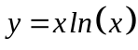
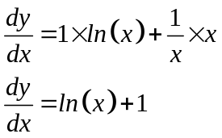
✓

✓

(2)
(iii) 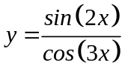
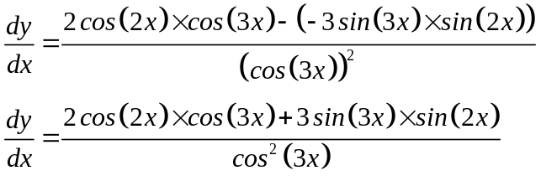
✓✓

✓

(3)
✓

(b) 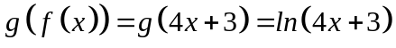
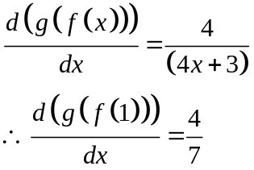
✓

✓

(3)
3. (5 marks)
✓✓

(a)
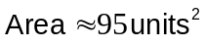
✓

(3)
(b) As the function is concave downwards, using rectangles from above gives
the better estimate of the area under the curve. (2)
✓✓

4. (8 marks)
(a) (i) 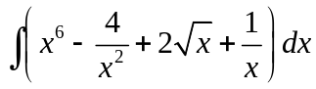
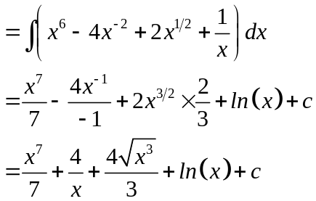
✓

✓

✓

(3)
(ii) 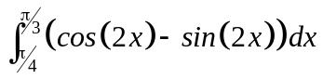
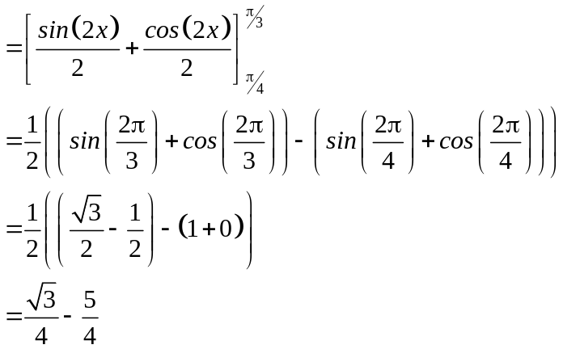
✓

✓

✓

(3)
(iii) 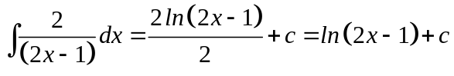 (1)
✓

(b) 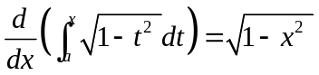 (1)
✓

5. (3 marks)
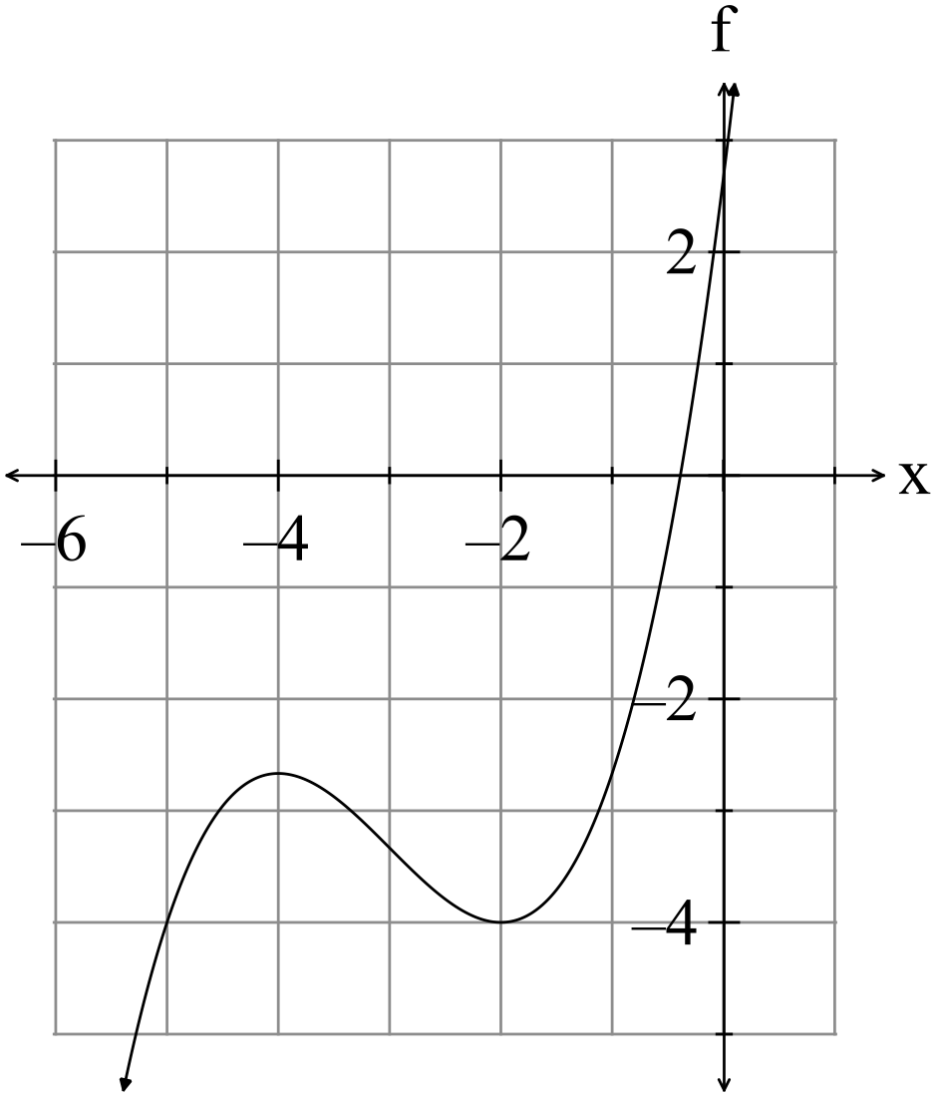
✓✓✓ -1/error

(3)
6. (2 marks)
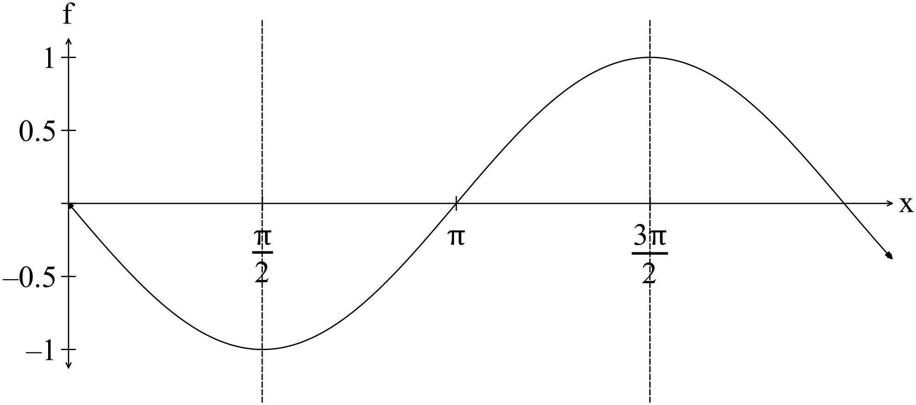 (2)
✓✓ -1/error

7. (9 marks)
(a)
x | 0 | 1 | 2 | 3
P(X = x) | 0.2 | 0.4 | 0.3 | 0.1

(i) Expected value 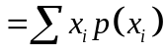
✓

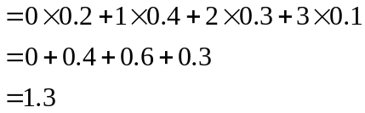
✓

(ii) (2)
Variance 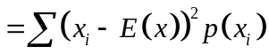
✓

✓

(2)
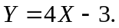
(iii) 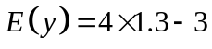
✓

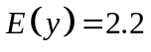 (1)
✓

(iv) 16 (1)

(b) (i) 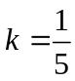 (1)
✓

(ii) 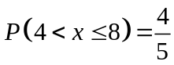 (2)
✓✓

8. (10 marks)
(a) On calculator get catalogue and select randList
✓✓✓

randList(10,1, 20) gives 10 random integers between 1 and 20. (3)
(b) The football attendees may or may not work in the city. They are not a random group of people so the population is not necessarily properly represented.
They may be a young group of people that could not afford the higher fees for parking in the CBC so feel strongly about it.
If the football field is in the city, they may feel strongly object to the increased fee for parking.
The group are not randomly selected so several types of bias may occur.
. (2)
✓✓ Accept anything sensible

(c) Each random sample will contain a set of different numbers.
This means the mean and standard deviations will differ. (2)
✓✓

(d) (i) Each sample mean is close to 0.7, the sample proportion mean of the population.
Some are a little higher, some a little lower, but they cluster around 0,7 and form a normal distribution with a mean of 0.7. (2)
✓✓

(ii) 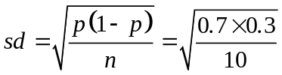 ✓ (1)

END OF SECTION ONE
SECTION TWO
9. (6 marks)
(a)
 | 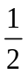
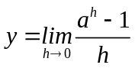 | -0.69 | 0 | 0.69 | 1.10 | 1.39  ✓✓
(2)
(b)
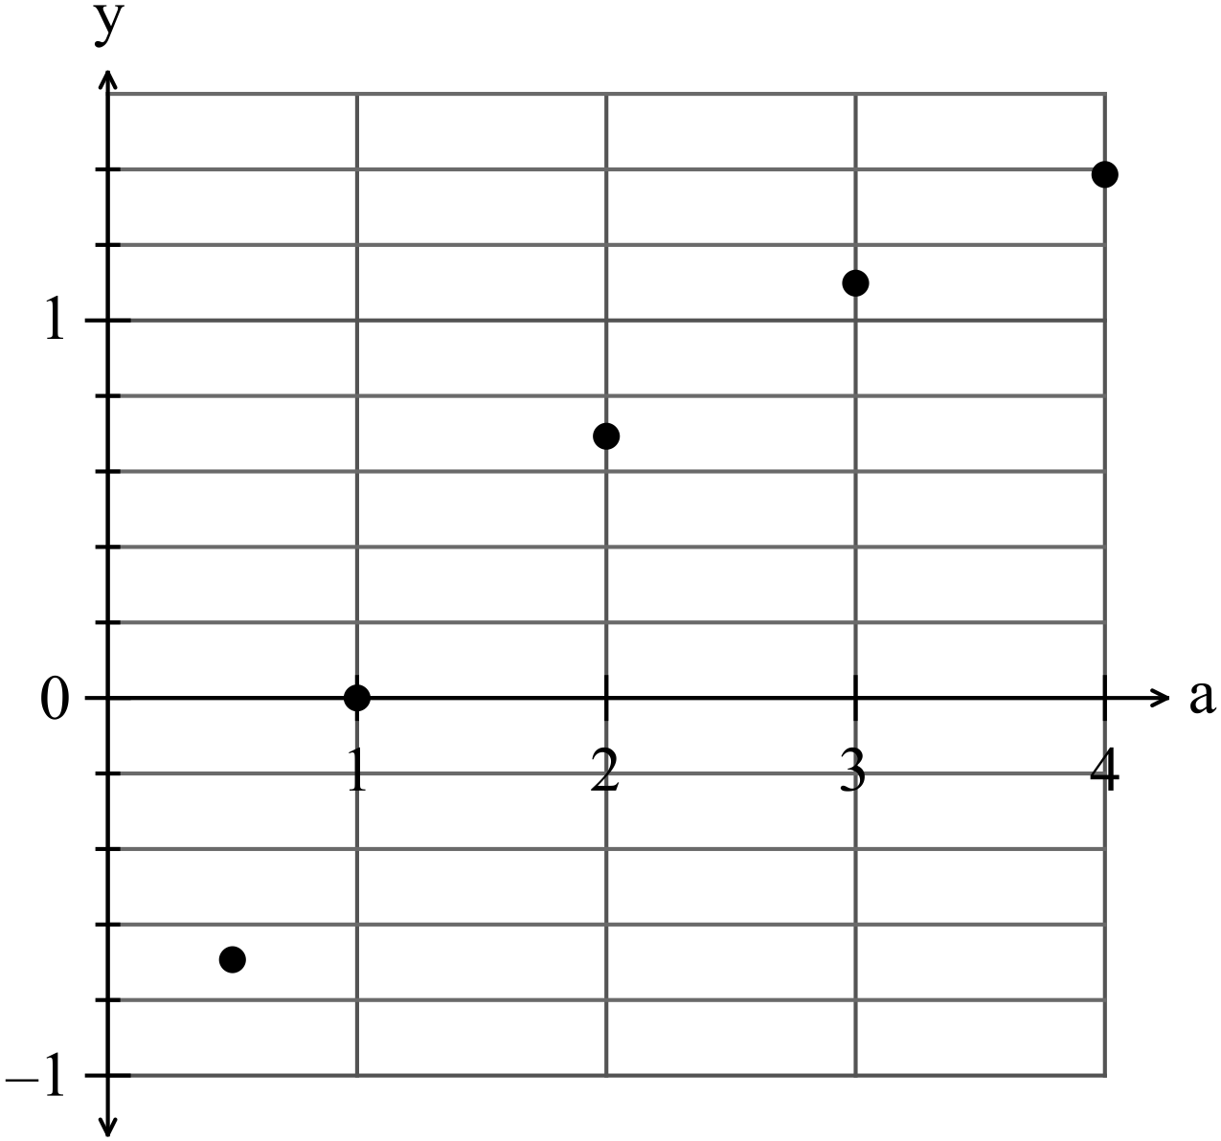
✓✓

(2)
(c) 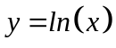 ✓ (1)

(d) e (1)
✓

10. (7 marks)
(a) 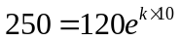
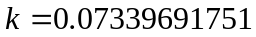 ✓ (1)

(b) 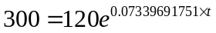
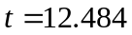
i.e. about 12 or 13 days ✓ (1)


(c) 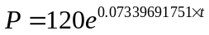
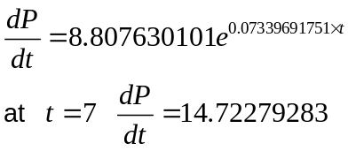
✓

The flu is spreading by about 15 people per week ✓ (2)
(d) 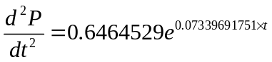 ✓
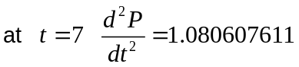 ✓
i.e. the rate of increase is increased by about 1 person per week (at t = 7). ✓(2)

(e) The function is always increasing.
After some time, the number of people getting the flu will decrease. This cannot
happen with this model. ✓ (1)

11. (5 marks)
(a) 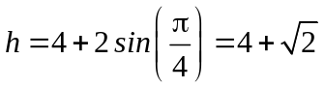 ✓ (5.414) (1)

(b) ✓ (1)

(c) 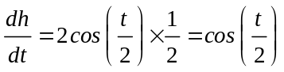 ✓
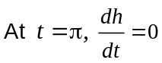 ✓ (1)

(d) 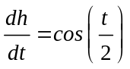
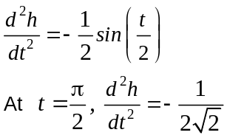 (2)
✓
✓
12, (4 marks)
(a) 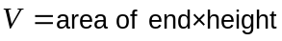
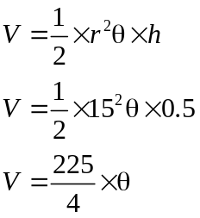
✓
(1)
(b) 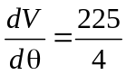
✓
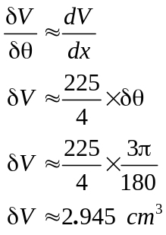
✓
✓
(3)
13. (14 marks)
(a) (i)
✓✓

t | N
1 | 6
2 | 18
3 | 54
4 | 162
5 | 486
(2)
(ii)
✓✓

t | ln(N)
1 | 1.79
2 | 2.89
3 | 3.99
4 | 5.09
5 | 6.19
(2)

(iii)
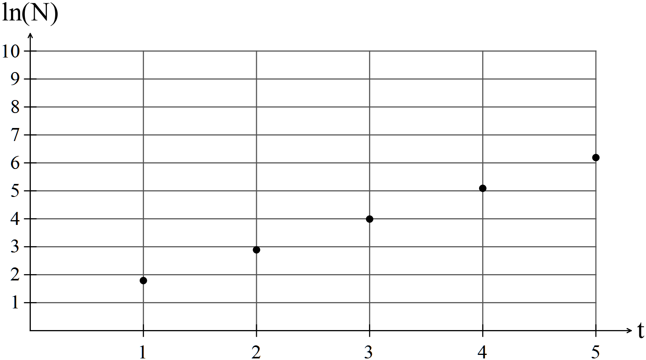
✓✓

(2)
(iv) Using ln(N) gives a linear function against t. The y scale is not so large so easier to plot ln N rather than N.
✓

It is easy to find to N by rearranging the linear formula.
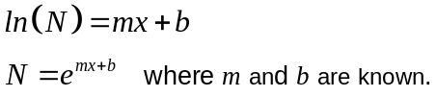
✓

(2)
(b)
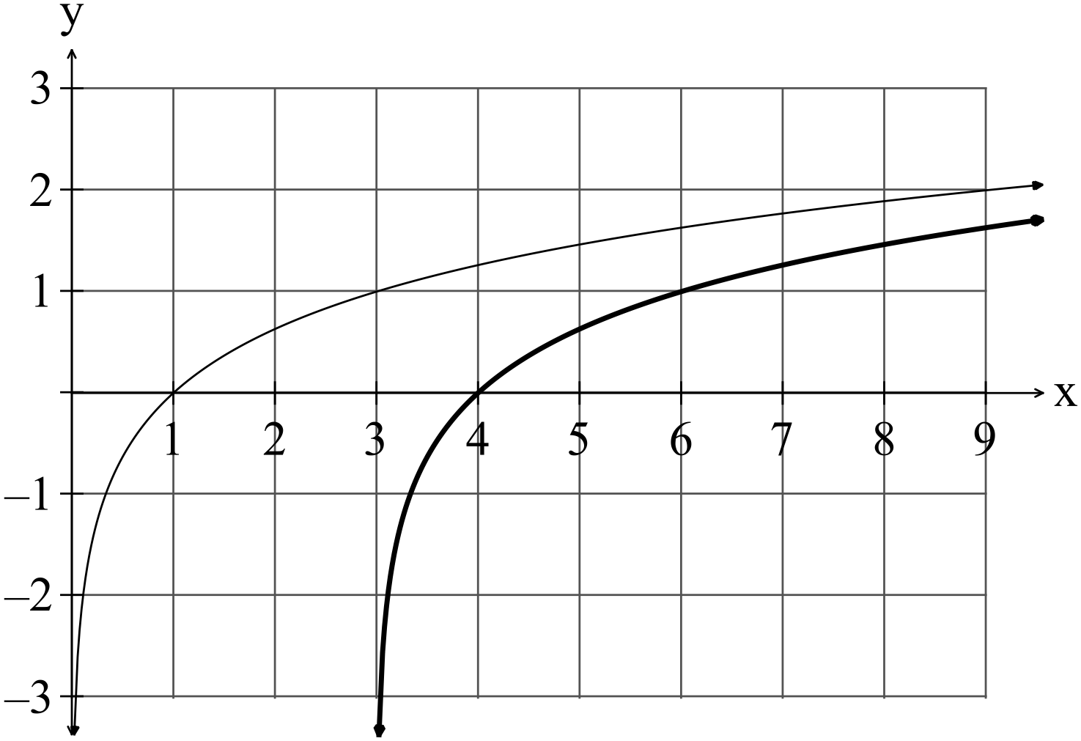
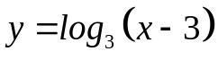

✓✓

(2)
(c) (i) 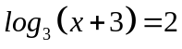
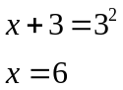
✓

✓

(2)
(ii) 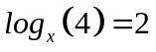
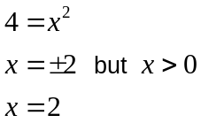
✓

✓

(2)
14. (6 marks)
(a) 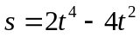
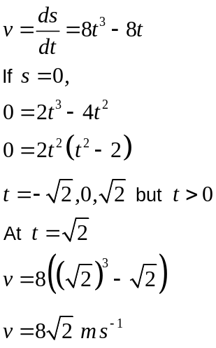
✓

✓

✓

(3)
(b) 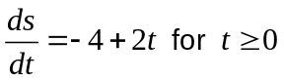
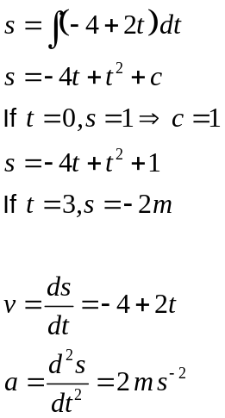
✓

✓

✓

(3)
15. (5 marks)
(a) 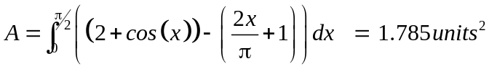 (2)
✓

✓

(b) (3)
✓

✓✓

16. (5 marks)
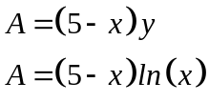
✓

Maximum area when 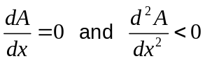
✓

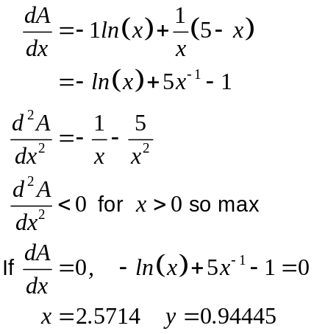
✓

✓

The point that maximises the area is 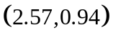. (5)
✓

17. (12 marks)
(a) (i) 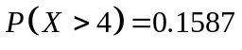 ✓ (1)
(ii) 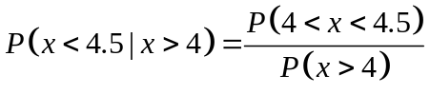 ✓
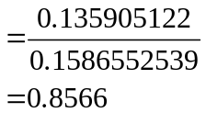
✓

(2)
(iii) 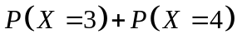
✓

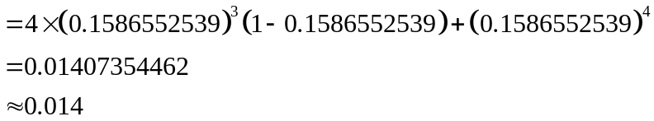
✓

(2)
(b) (i)
✓✓ -1/error

x | 0 | 1 | 2 | 3 | 4
P(X = x) | 0.067 | 0.267 | 0.367 | 0.247 | 0.053
(2)
(ii)
✓✓ -1/error

x | 0 | 1 | 2 | 3 | 4
P(X = x) | 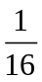 | 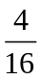 | 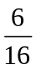

or 0.0625 0.25 0.375 0.25 0.0625 (2)

(iii) 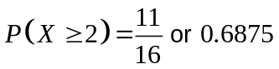 ✓ (1)

(iv) 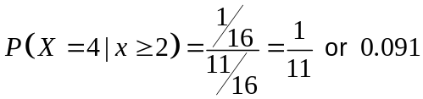 ✓ (2)
✓

18. (8 marks)
(a) P(three of the cars had the petrol cap on the driver’s side of the car)
= 0.2541 ✓✓
(b) P(no more than three of the cars had the petrol cap the driver’s side of the car)
= 0.8059 ✓✓
(c) P(none of the cars had the petrol cap on the driver’s side of the car)
= 0.0576 ✓✓
(d) P(the last five cars had their petrol cap on the other side of the car)
= 0.1681 ✓✓
(8)
19. (14 marks)
(a) 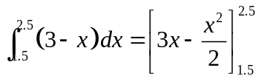
✓

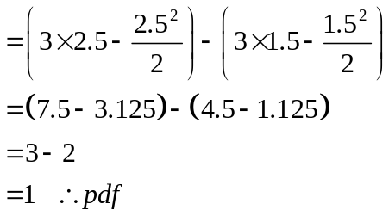
✓

✓

(3) (b) 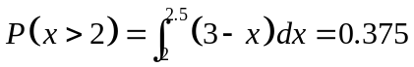 ✓✓ (2)

(c) 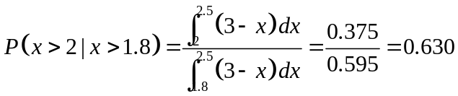 (2)
✓

✓

(d) 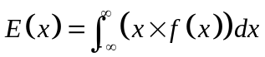
✓
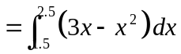
✓

(3)
(e) 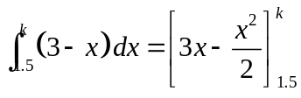
✓
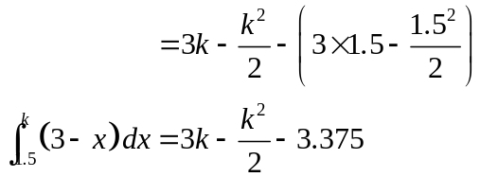
✓
Therefore the cumulative probability density function is
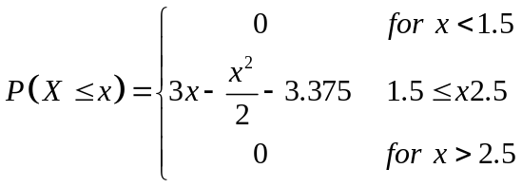
✓

(f) 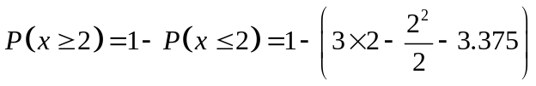 ✓
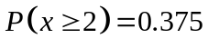 ✓ (2)
20. (12 marks)
(a) 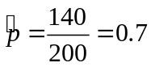
✓
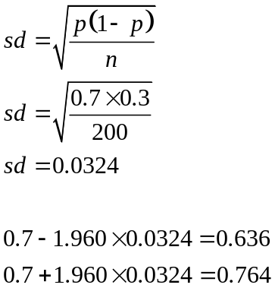
✓
✓
✓
We can be 95% sure that the percentage of Shenton Park ratepayers that do not
want Shenton College moved to Perth CBD is between 64% and 76%.
✓
(5)
(b)
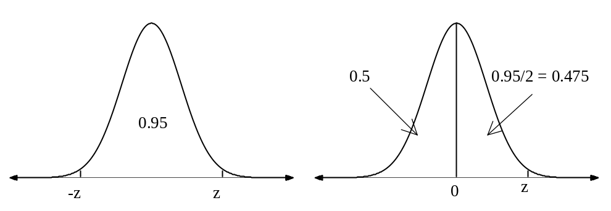
P(X< z) = 0.975
So, 95% confidence level means z = 1.96
✓
✓
Use 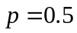 as the estimate of the sample proportion as is unknown.
NB This maximises 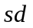so covers all smaller cases of 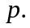
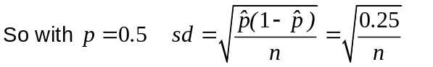
✓
E = z × s but 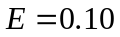
Therefore
✓
0.10 = 1.96×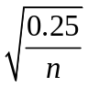
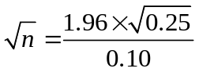
n = 96.04
✓
n ≈ 96
Should use a sample size of 96 people to have a confidence level of 95% with an
error margin of 10%.
(5)

(c) For the confidence level of 95%
✓
For the confidence level of 90%
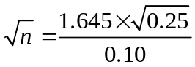
✓

n = 67.65 i.e. n = 68

For a lower confidence level, n can be less. (2)

END OF SECTION TWO

